Order Of Service

Singing: Psalm 90—CW page 99

Reading: Psalm 140

Opening Hymn: TLH 128

Reading: I Peter 1:3-12

Request Hymn: CW Supplement 735

Reading: Luke 20:41-47

Sermon Hymn: TLH 245

Sermon Text: Song Of Solomon 2:5

Sick Of Love

Prayer

The Apostles’ Creed, TLH page 12

Holy Communion

The Lord's Prayer

The Blessing

Closing Hymn: TLH 46

* * * * * * * * * * *

Bible Study: Lambs: Psalm 92:1; Giving Thanks
Sheep: Proverbs 6:20-25; Your Choice


The Marsh—God’s Country

Water
Of
Life

22 November 2015

W A T E R O F L I F E

Independent Christian Church—Conservative Lutheran Doctrine

Worship Service: 9:30 a.m. Bible Study: 10:45 a.m.

Larry Cooper, Pastor E-Mail address:
111 N. Ridge Road lcooper@wateroflife.cc
Coon Valley, WI 54623 Web Site:
Phone: (608) 452-2105 www.wateroflife.cc

* * * * * * * * * * * * * * * * * * * * * * * * * * *

Sermon Text: Song Of Solomon 2:5

Sick Of Love

* * * * * * * * * * * * * * * * * * * * * * * * * * *

2:5 Stay me with flagons, comfort me with apples: for I am sick of love.

The Marriage

Chapter two of the Gospel of John begins with these words: “And the third day there was a marriage in Cana of Galilee; and the mother of Jesus was there: And both Jesus was called, and his disciples, to the marriage.”

This was the setting in which the Son of God performed his first miracle during his ministry on this earth. You know the story: When the supply of wine ran out, Jesus told the servants to fill six water pots of stone with water. When they had finished doing that, he told them to “draw out now, and bear unto the governor of the feast.” When the ruler of the feast had tasted the water that was made wine, he called the bridegroom and said to him—“Every man at the beginning doth set forth good wine; and when men have well drunk, then that which is worse: but thou hast kept the good wine until now.”

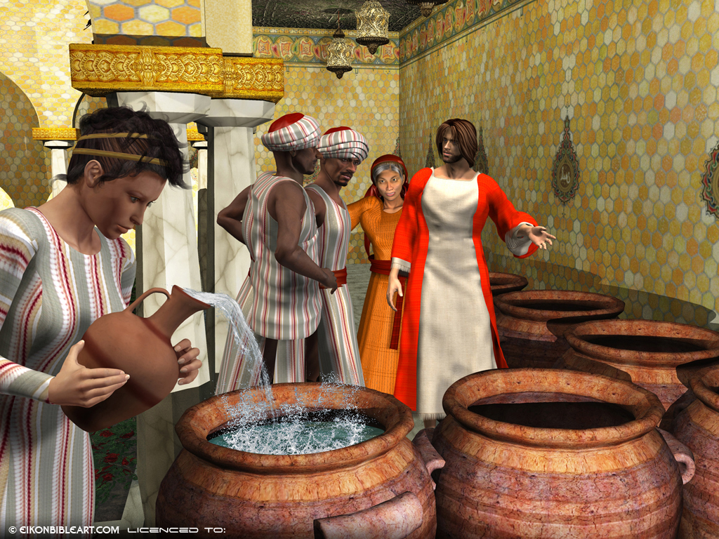

Notice that this miracle took place on the third day. In Scripture, the number three often points to the resurrection. And all history, from Eden to the great day when Christ returns, is moving toward that blessed marriage between the Son of God and his Bride. The promise is—“I go to prepare a place for you. And if I go and prepare a place for you, I will come again, and receive you unto myself: that where I am, there ye may be also.”

Here in Song Of Solomon the Bride is looking forward to the fulfillment of this promise of her Bridegroom. She is “sick of love.” And when he tells her, “Surely I come quickly,” her response is—“Even so, come, Lord Jesus!” Revelation 22:20.

